Big Data – Assignment 1

Part 2a:

The output of the command: show table status from classicmodel;

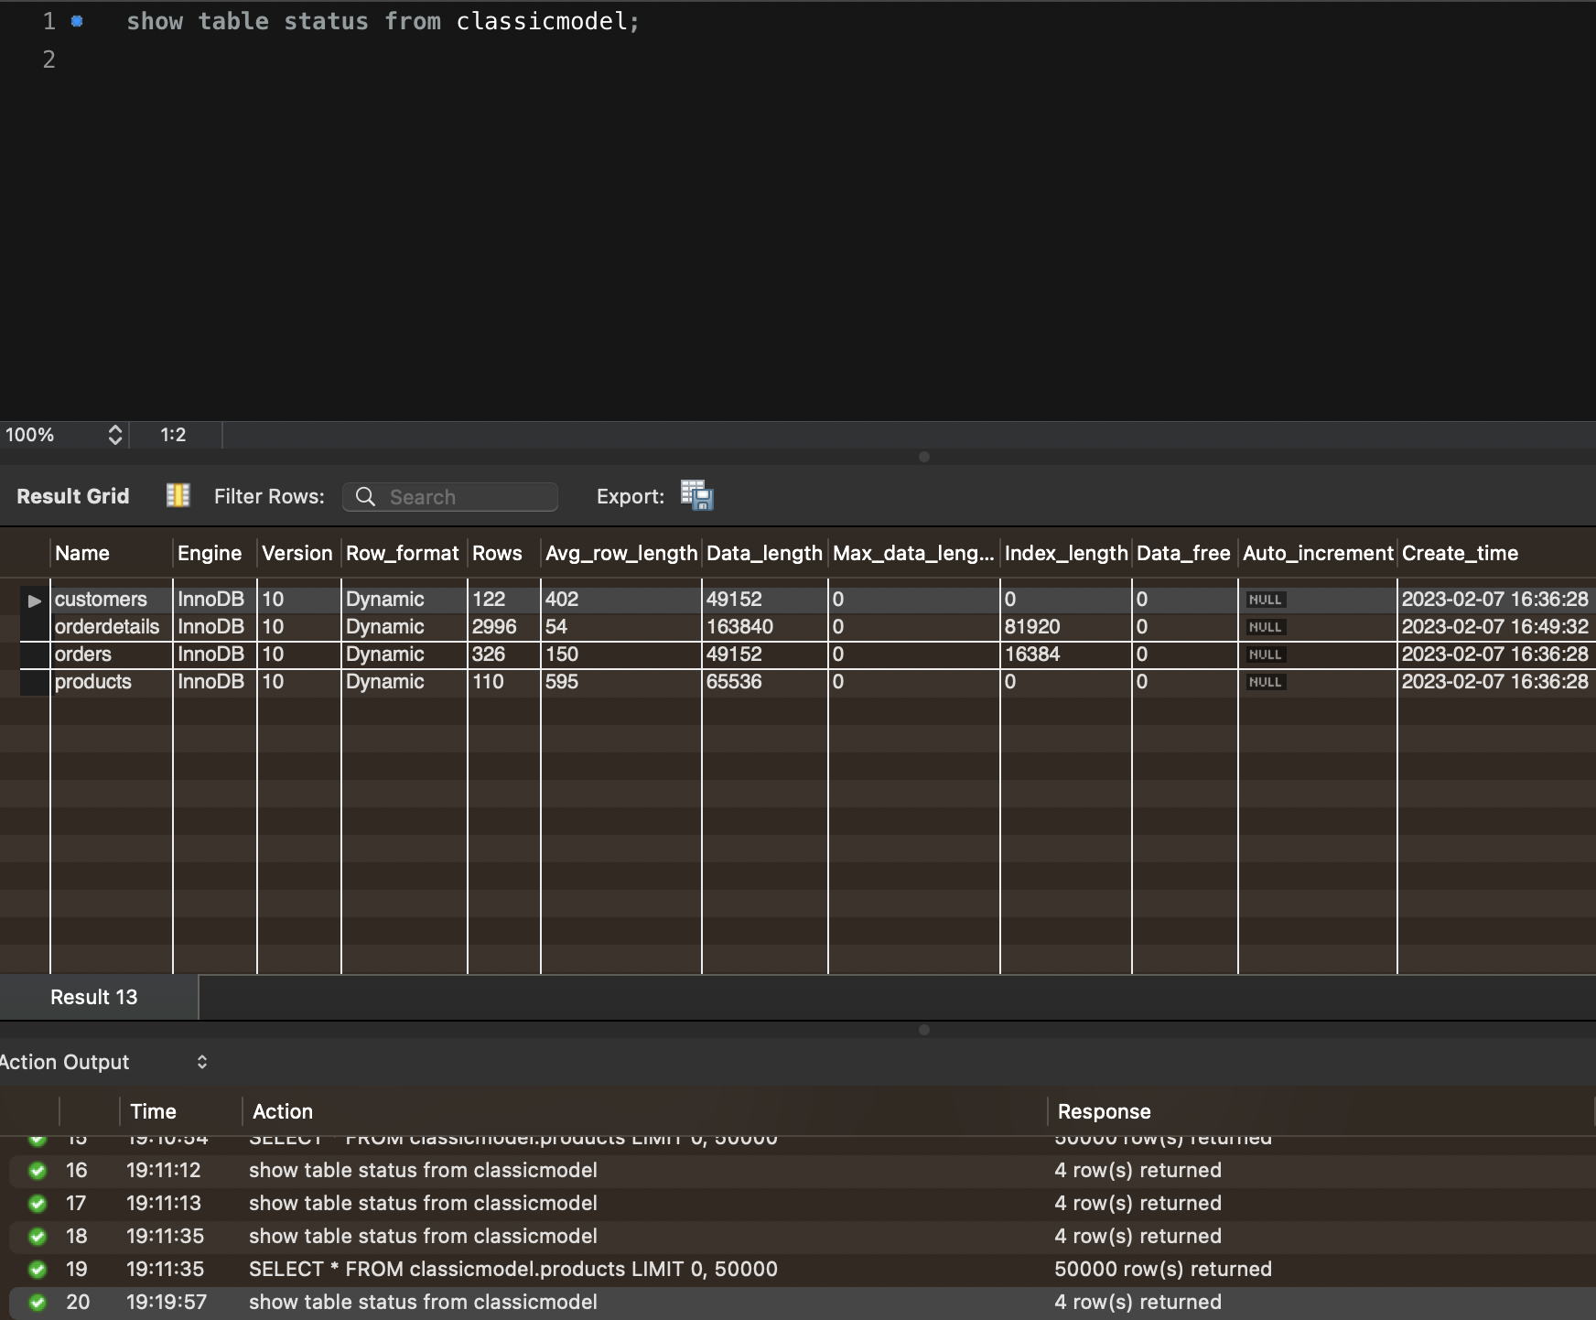

Query Analysis

Explain Analyze query (8) from. How can you improve the execution?

The output of the EXPLAIN ANALYZE command shows that the query is using a temporary table with deduplication, and performing a nested loop inner join between the orderdetails and products tables. It also shows that a covering index scan is used on the orderdetails table, and a single-row index lookup is used on the products table.

The query is currently not optimized for performance, as it is using a nested loop join which can be slow for large datasets. A possible way to improve the execution is to use a different join method, such as a hash join or a merge join, which may be faster for the given tables and data. Additionally, creating an index on the quantityInStock column of the products table may improve the performance of the query.

Commands for improving performance:

*CREATE INDEX idx_orderdetails_productCodeNo ON classicmodel.orderdetails (productCode);*

*CREATE INDEX idx_products_quantityInStock ON classicmodel.products (quantityInStock);*

*ALTER TABLE classicmodel.orderdetails*

*ADD INDEX idx_orderdetails_products (productCode, quantityInStock);*

MySQL plans and Execution time before and after

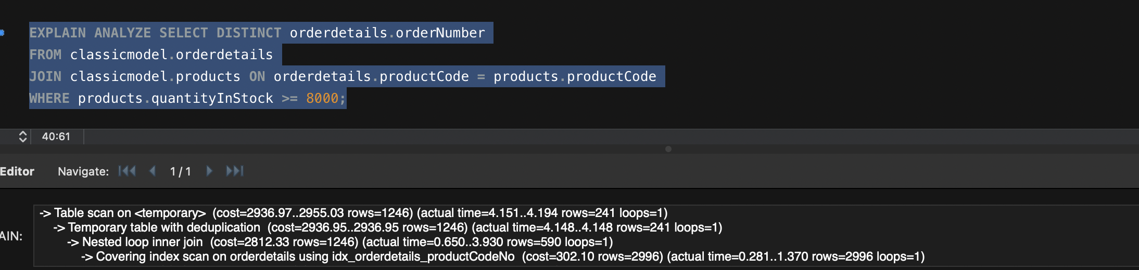

Results discussion

The output of EXPLAIN ANALYZE after adding the new index shows a reduced cost and actual execution time, indicating that the query is more efficient. The query plan shows that the query is using the new index "idx_orderdetails_productCodeNo" that was created earlier, resulting in a covering index scan on the orderdetails table.

Therefore, the new index has improved the performance of the query.